[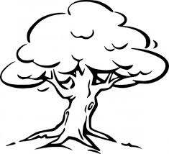](http://www.google.com.au/url?sa=i&rct=j&q=&esrc=s&source=images&cd=&cad=rja&uact=8&docid=Q-jachXC6K5l9M&tbnid=dEZcnnM6t4ztbM:&ved=0CAUQjRw&url=http://all-free-download.com/free-vector/vector-clip-art/tree_outline_clip_art_11785.html&ei=gkD1U_q5CIzp8AXO4oLQAQ&bvm=bv.73231344,d.dGc&psig=AFQjCNFOn96papxJpTkYcyqtzYCWu8mjvQ&ust=1408668120729314)Biological Science Year 7

Mid Topic Test

Name: _______________________________________ Total: 70 marks

Part A: Multiple-Choice (10 marks)

1. Which of the following all belong to the phylum Arthropoda?

**A** ants, bees, grasshoppers, crabs and spiders.

**B** snails, ticks, moths, prawns and worms.

**C** birds, bees, ants, butterflies and snails.

**D** earthworms, flatworms, roundworms and tapeworms.

2. At each stage in a dichotomous key there are:

**A** four choices.

**B** two choices.

**C** two or three choices.

**D** one choice.

3.When writing a classification key for people, a strong feature would be something like:

**A** hair length.

**B** hair colour.

**C** eye colour.

**D** all of the above.

4. Which of the following shows the order of classification from largest group to smallest group?

**A** kingdom, phylum, class, order, family, genus, species.

**B** species, genus, family, order, class, phylum, kingdom.

**C** kingdom, phylum, order, class, family, species, genus.

**D** genus, species, order, family, class, phylum, kingdom.

5. The five kingdoms are:

**A** animal, plant, protist, arthropod and fungi.

**B** animal, plant, porifera, monera and fungi.

**C** animal, plant, protist, monera and aves.

**D** animal, plant, protist, monera and fungi.

6. All Cnidaria have the following characteristics:

**A** live in water, bilateral symmetry and a backbone.

**B** live in water, radial symmetry and stinging cells.

**C** radial symmetry, live on land and have a backbone.

**D** bilateral symmetry, segmented bodies and live in damp areas.

7. The plant kingdom is broken into three divisions based on:

**A** the way they reproduce and their transport system.

**B** if they have flowers or not.

**C** their colour and the way they reproduce.

**D** if they have seeds or not.

8. Mammals are broken into the following groups:

**A** marsupials, monotremes and agnatha.

**B** monera, monotremes and placentals.

**C** marsupials, monotremes and placentals.

**D** marsupials, monotremes and endoderms.

9. The three phyla to which worms belong are:

**A** nematode, mollusc and annelid.

**B** chordate, platyhelminthes and annelid.

**C** nematode, platyhelminthes and arthropod.

**D** nematode, platyhelminthes and annelid.

10. The scientific name of an organism tells you its:

**A** genus and species.

**B** class and species.

**C** kingdom and phylum.

**D** order and family.

**Part 2: Short Answer**

1. **Match** the following terms with their correct meaning. Note: not all words will be used.

Classification, taxonomist, dichotomous key, taxonomy, kingdom, class, phylum, microscopic, macroscopic, multicellular, unicellular, amphibians, reptiles, aves, mammals, chordates, conifers, endoskeleton, exoskeleton, molluscs, parasite, flowering plant,

a) Made of many cells ____________________________ Multicellular

b) Cannot be seen with the naked eye ________________ Microscopic

c) A key with two choices at each stage ______________ Dichotomous

d) The process of putting things into groups ___________Classification

e) An organism that lives on or in another organism _____ Parasite

f) A scientist that specialises in grouping and naming things ___Taxonomist

g) The first level of classification ________________________ Kingdom

h) Plants that have seeds in cones _______________________ Conifer

i) Class of chordates that contains frogs __________________ Amphibians

j) Animals with a nerve cord running down their back _______ Chordates

(10 marks)

2. a) **Draw** and **label** a dichotomous key for the shapes below:

All four shapes classified out with only 2 choices at each point

(5 marks)

b) **Describe** how a dichotomous key is different to other keys ___________________________

You only have two choices at each stage. They can be a flow chart or a table.

___________________________________________________________________________

___________________________________________________________________________

(2 marks)

3. Chordates are one phyla of the animal kingdom. Answer the following questions about chordates:

1. **State** the unique characteristic of marsupials ? ___________ a pouch
2. **State** which class snakes belong to? ____________________ reptiles

1. **List** two classes of chordate you have not already used __ mammal, aves, amphibian, fish

(4 marks)

4. **Justify** the following statement:

1. Platypus are mammals, however, they are not in the same subclass as most other mammals.

They lay eggs which other mammals don’t do, but they do have hair and feed their babies on milk

___________________________________________________________________________

(2 marks)

5. **Explain** how organisms are given their scientific name: ______________________________

They use their genus name first and then their species name

___________________________________________________________________________

(2 marks)

6. **Classify** the following as radial or bilateral symmetry:

1. starfish ______________ radial
2. jellyfish _____________ radial
3. earthworms ___________ bilateral
4. humans ______________ bilateral

(4 marks)

7. **Identify** one example of an individual in the following phylum:

1. Poriferan _____ sponge
2. Cniderian _____jellyfish, sea anemone, coral polyp
3. Mollusc ______ snail, slug, oyster, octopus
4. Echinoderm ____ sea urchin, starfish, sea cucumber
5. Arthropod ______ insects, spiders, crustaceans, centipedes, millipedes

(5 marks)

8. The following picture shows some Australian owls. Mask refers to the face shape.

Answer the questions on the following page using the key. 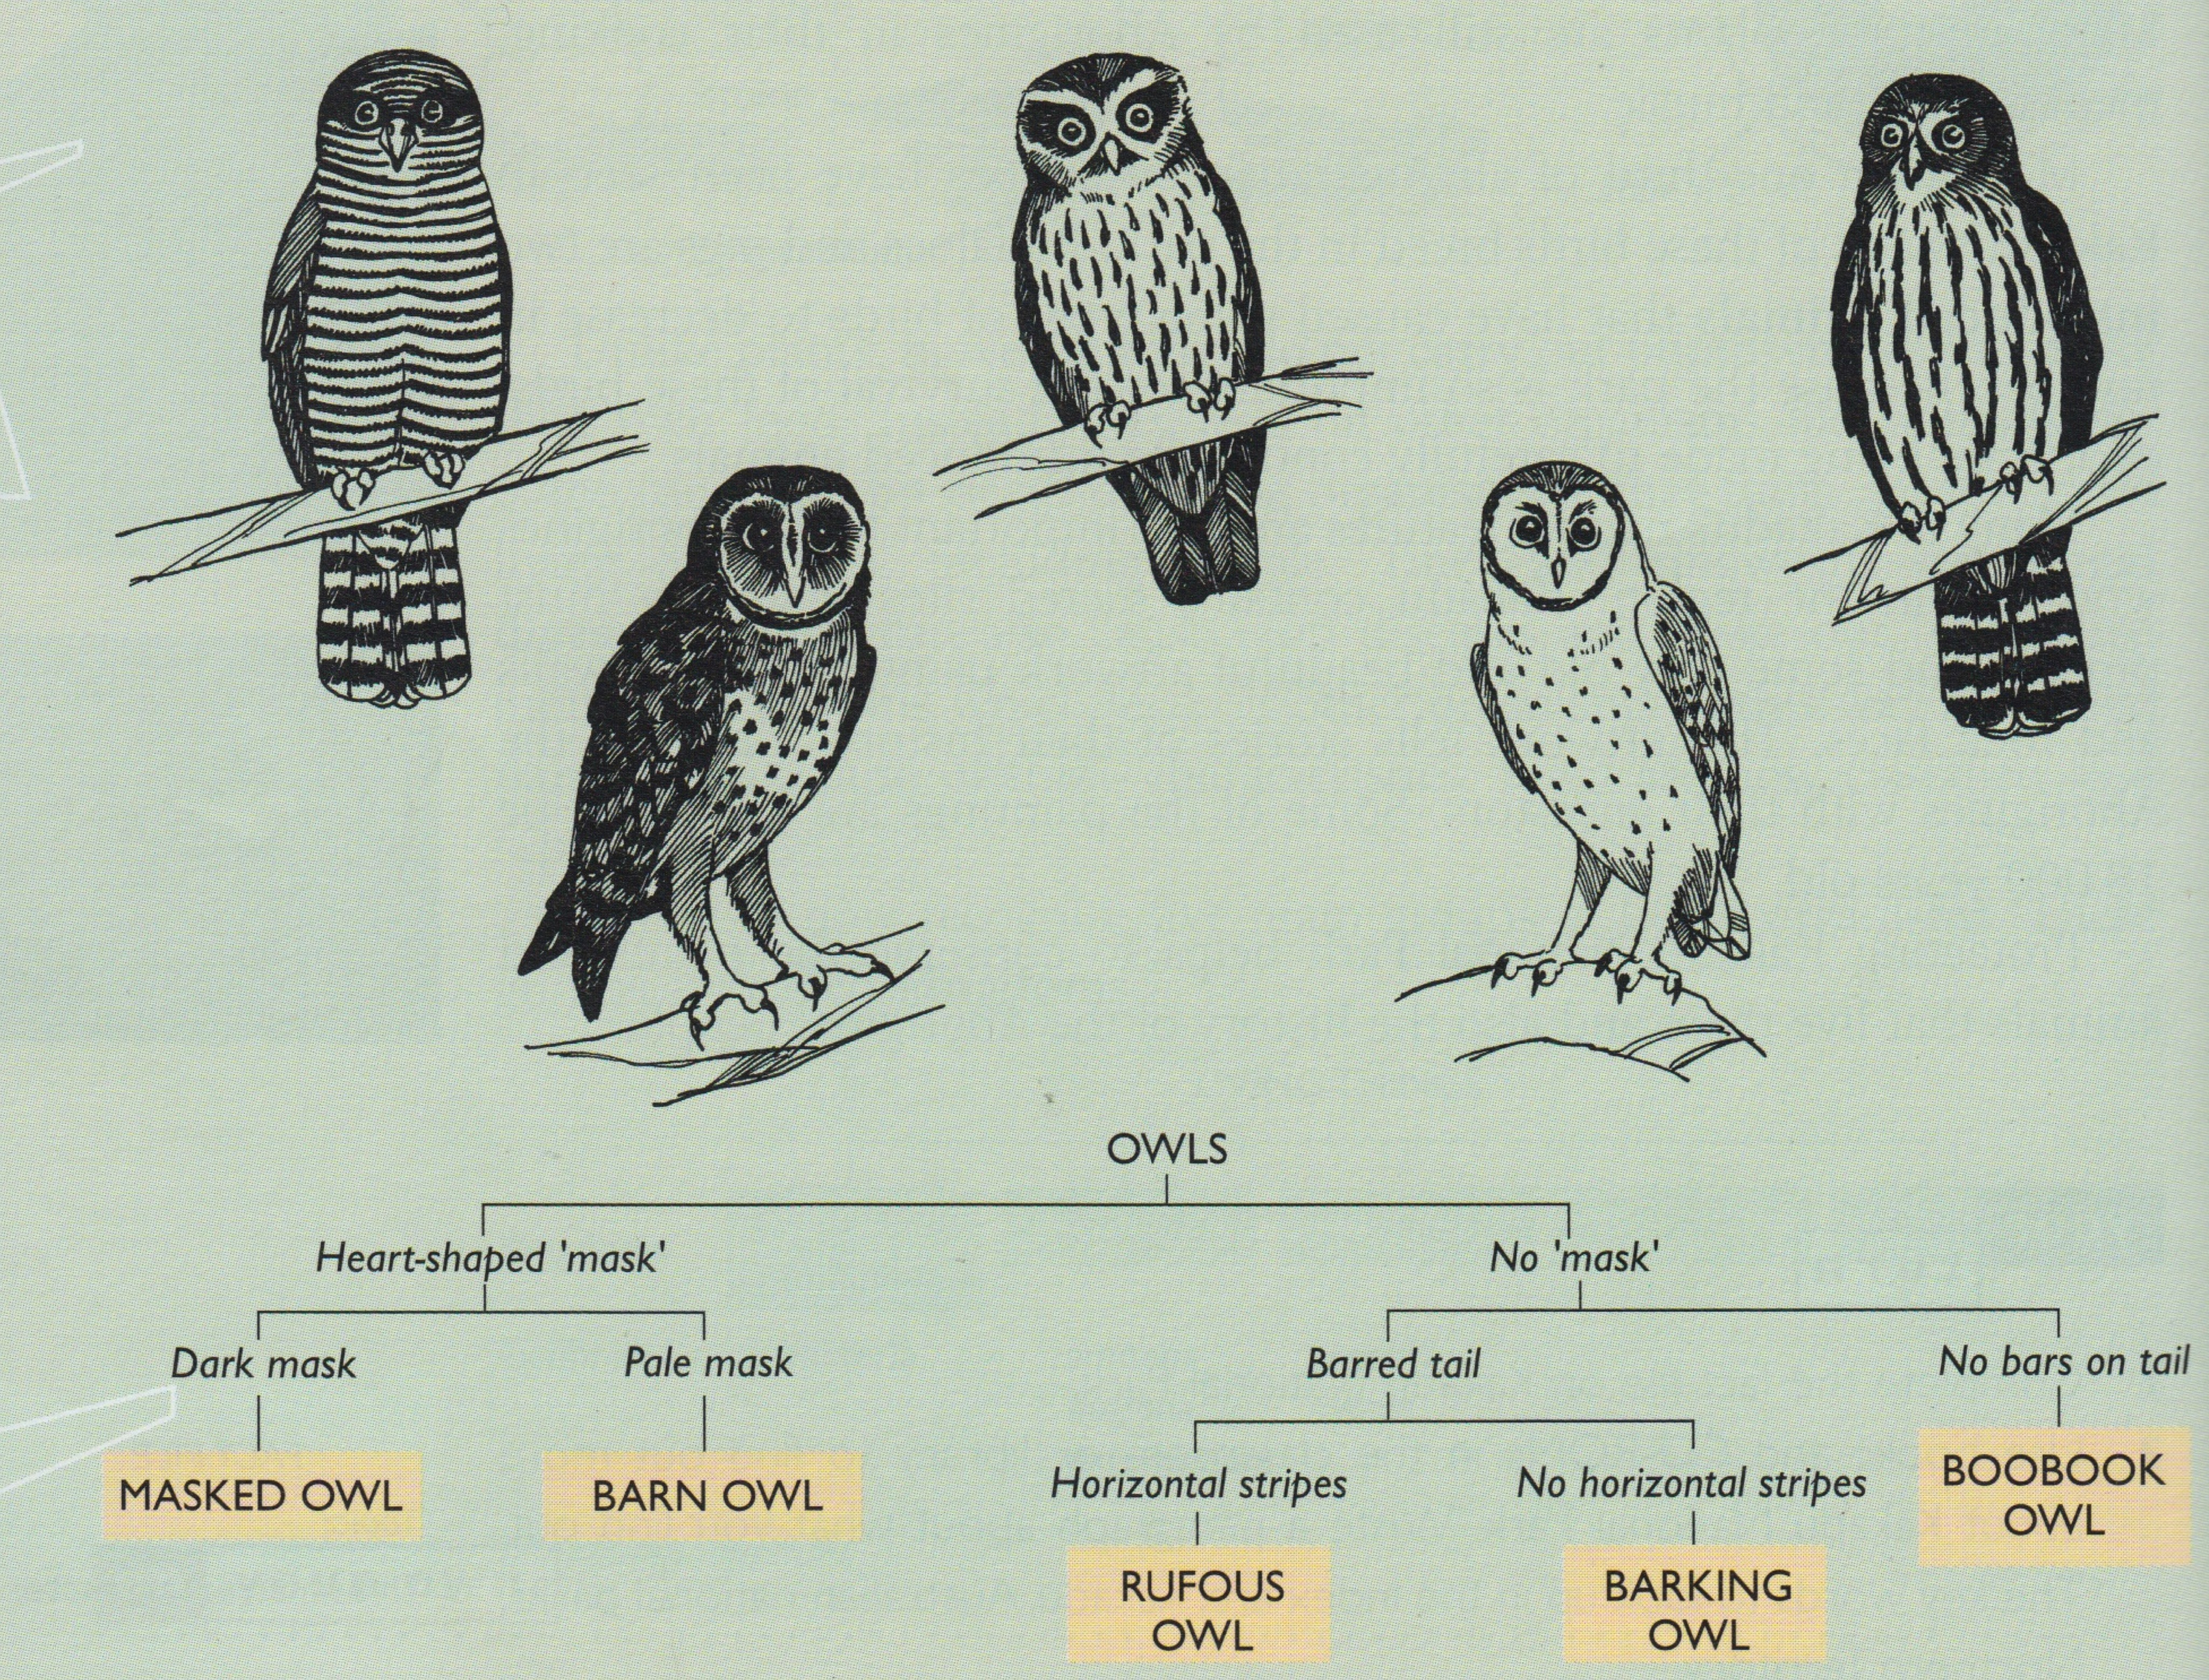

a) Use the key to **identify** each owl. Write their name next to their picture on the key.

Left to right – rufous, masked, boobook, barn, barking owl (5 marks)

b) **Identify** one other feature that could be used to classify any of the owls _________________

spotted chest, dark patches around the eyes….

(1 mark)

c) **State** why this key is a ‘strong’ key ______________________________________________

because the characteristics are things that don’t change and easy to observe.

___________________________________________________________________________

(1 mark)

9. The following table shows the number of identified species in each phylum.

|  |  |
| --- | --- |
| **Phylum** | **Number of species in the phylum** |
| Porifera | 500 |
| Cnidaria | 9 000 |
| Nematoda | 20 000 |
| Arthropoda | 1 230 000+ |
| Platyhelminthes | 20 000 |
| Mollusca | 100 000 |
| Annelida | 15 000 |
| Echinodermata | 7 000 |
| Chordata | 52 675 |

Title, axis labelled, scale correct, plotted correctly

a) Graph the results above as a column graph. (5 marks)

b) Which **two** phyla have the least number of species ____________________________

___________ porifera and echinoderms

(2 mark)

c) Which **two** phyla have the most number of species ____________________________

Arthropoda and mollusca

(2 mark)

d) **Compare** Platyhelminthes and Mollusca ___________________________________

Mollusca has 100 000 and platy has 20 000

___________________________________________________________________________

(2 marks)

e) If scientists were to find and name 52 new species in the phylum Porifera, **estimate** the percentage increase this would represent

10%

(1 mark)

f) **Explain** why the number of species increase every year.

Because scientists keep finding new species of plants and animals

___________________________________________________________________________

(2 mark)

10. **Define** the following:

i) exoskeleton ___________________________________________________________

_____________ a skeleton on the outside

ii) monotreme ___________________________________________________________

_____________ an egg laying mammal

iii) fungi _________________________________________________________

the kingdom of organisms that cannot make their own food and feed on other organisms

iv) vertebrate ____________________________________________________________

animals with a backbone

v) endothermic __________________________________________________________

animals that can control their body temperature internally

(5 marks)